**Practical no.-**23

**Title:** Develop a program to build Camera

**Roll No.:**15 **Batch-** A **Date of Performance:** 07/03/2024

**activity_main.xml**

<?xml version="1.0" encoding="utf-8"?>

<AbsoluteLayout xmlns:android="http://schemas.android.com/apk/res/android" xmlns:app="http://schemas.android.com/apk/res-auto" xmlns:tools="http://schemas.android.com/tools"

android:layout_width="match_parent"

android:layout_height="match_parent"

tools:context=".MainActivity">

<ImageView

android:id="@+id/img"

android:layout_width="279dp"

android:layout_height="308dp"

android:layout_x="40dp"

android:layout_y="79dp"

android:text="Hello World!" />

<Button

android:id="@+id/btn"

android:layout_width="wrap_content"

android:layout_height="wrap_content"

android:layout_x="94dp"

android:layout_y="447dp"

android:text="Capture Image" />

</AbsoluteLayout>

**MainActivity.java**

package com.example.pract_231camera;

import androidx.appcompat.app.AppCompatActivity;

import android.annotation.SuppressLint;

import android.content.Intent;

import android.graphics.Bitmap;

import android.os.Bundle;

import android.provider.MediaStore;

import android.view.View;

import android.widget.Button;

import android.widget.ImageView;

public class MainActivity extends AppCompatActivity {

Button btn;

ImageView img;

protected void onCreate(Bundle savedInstanceState) {

super.onCreate(savedInstanceState);

setContentView(R.layout.activity_main);

btn = (Button) findViewById(R.id.btn);

img = (ImageView)

findViewById(R.id.img);

btn.setOnClickListener(new View.OnClickListener() {

public void onClick(View v) {

Intent incamera = new Intent(MediaStore.ACTION_IMAGE_CAPTURE);

startActivityForResult(incamera, 0); }});}

protected void onActivityResult(int requestcode, int resultcode, Intent data)

{ super.onActivityResult(requestcode,resultcode,data);

Bitmap photo=(Bitmap) data.getExtras().get("data");

img.setImageBitmap(photo);

}

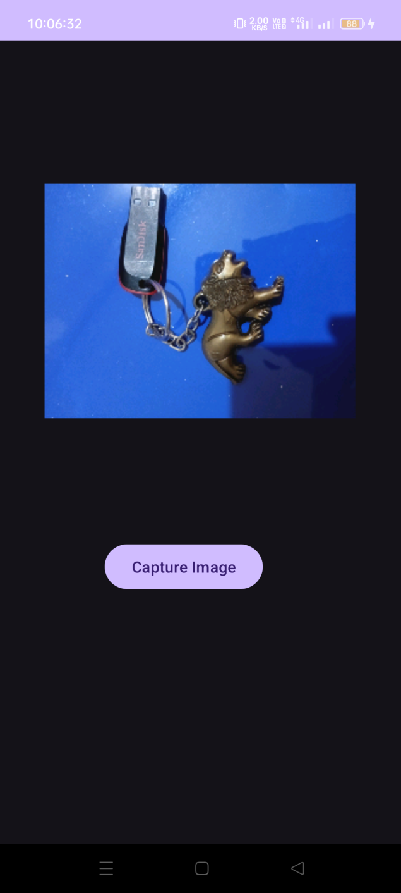}

**activity_main.xml**

<?xml version="1.0" encoding="utf-8"?>

<AbsoluteLayout xmlns:android="http://schemas.android.com/apk/res/android"

xmlns:app="http://schemas.android.com/apk/res-auto"

xmlns:tools="http://schemas.android.com/tools"

android:layout_width="match_parent"

android:layout_height="match_parent"

tools:context=".MainActivity">

<VideoView

android:id="@+id/vdo"

android:layout_width="match_parent"

android:layout_height="match_parent"

android:layout_x="0dp"

android:layout_y="80dp" />

<Button

android:id="@+id/btn"

android:layout_width="wrap_content"

android:layout_height="wrap_content"

android:layout_x="111dp"

android:layout_y="26dp"

android:text="Record Video" />

</AbsoluteLayout>

**MainActivity.java**

package com.example.pract_232video;

import androidx.annotation.Nullable;

import androidx.appcompat.app.AppCompatActivity;

import android.annotation.SuppressLint;

import android.content.Intent;

import android.net.Uri;

import android.os.Bundle;

import android.provider.MediaStore;

import android.view.View;

import android.widget.Button;

import android.widget.MediaController;

import android.widget.VideoView;

public class MainActivity extends AppCompatActivity {

VideoView vdo;

Button btn;

@SuppressLint("MissingInflatedId")

@Override

protected void onCreate(Bundle savedInstanceState) {

super.onCreate(savedInstanceState);

setContentView(R.layout.activity_main);

vdo=(VideoView) findViewById(R.id.vdo);

btn=(Button) findViewById(R.id.btn);

MediaController mcontroll=new MediaController(this);

mcontroll.setAnchorView(vdo);

vdo.setMediaController(mcontroll);

btn.setOnClickListener(new View.OnClickListener() {

@Override

public void onClick(View v) {

Intent videocam=new Intent(MediaStore.ACTION_VIDEO_CAPTURE);

startActivityForResult(videocam,0);

}

});

}

@Override

protected void onActivityResult(int requestCode, int resultCode, @Nullable Intent data) {

super.onActivityResult(requestCode, resultCode, data);

if(resultCode==RESULT_OK && requestCode==0)

{

Uri vidouri=data.getData();

vdo.setVideoURI(vidouri);

vdo.start();

}

}

}

